🎯 Project: End-to-End Data Pipeline on GCP
🗣️ How to Start in Interview
You can begin like this:
“I worked on building an end-to-end data ingestion and processing pipeline on Google Cloud Platform, where I handled data from multiple sources like SAP and Oracle, processed it, and made it available for analytics in BigQuery.”

🔁 Step-by-Step Explanation

🔹 Step 1: Data Ingestion (Getting Data)
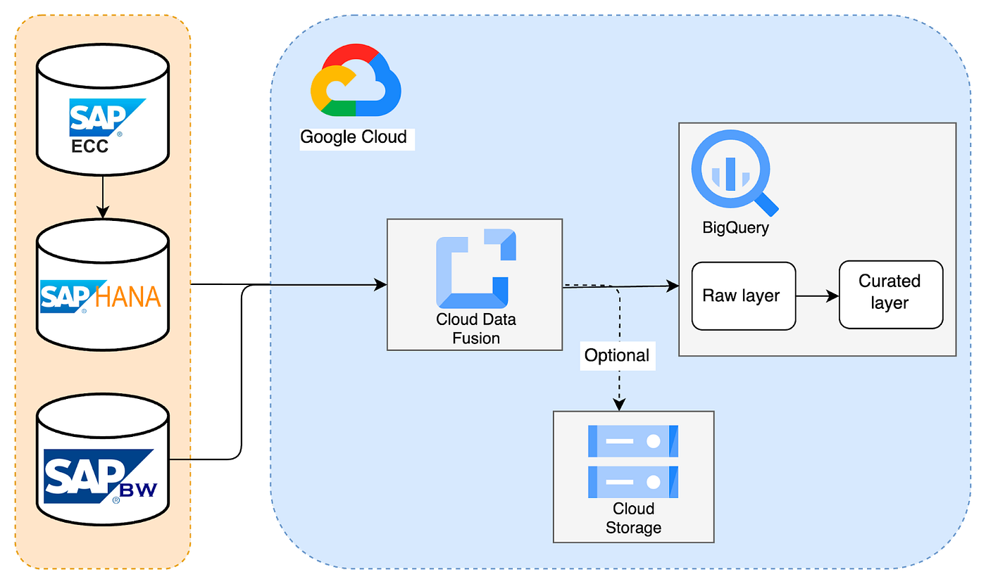
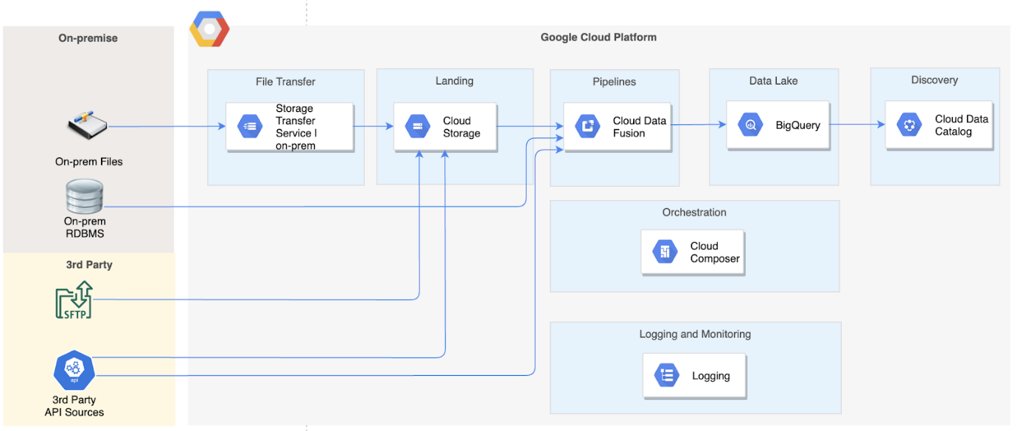
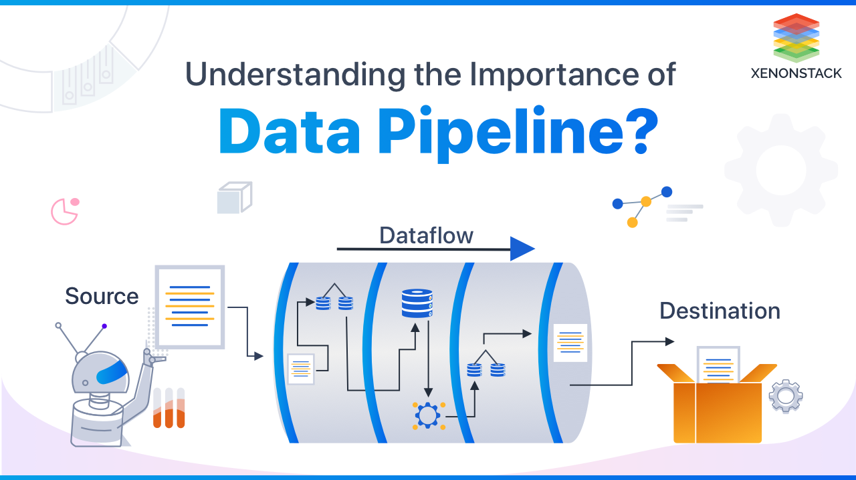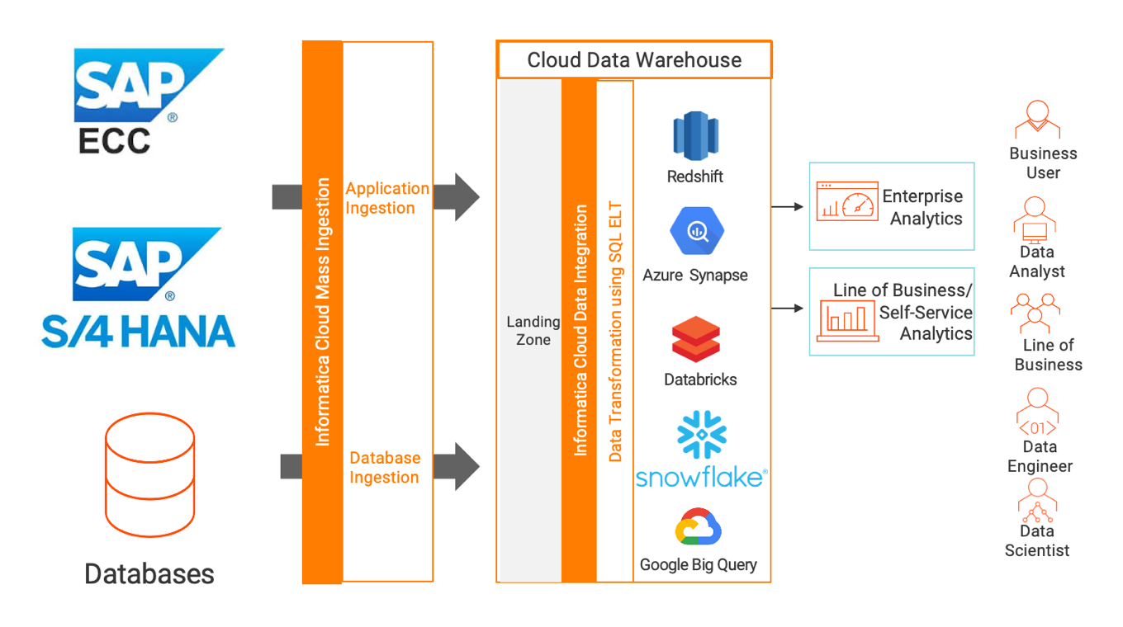

What you did:
- Collected data from:
  - SAP HANA
  - Oracle
  - Other enterprise systems

Tools used:
- GCS (Google Cloud Storage)
Simple explanation:
👉 “We first bring raw data into cloud storage.”
Example:
- Sales data from SAP → stored as CSV in GCS

🔹 Step 2: Data Processing (ETL/Transformation)
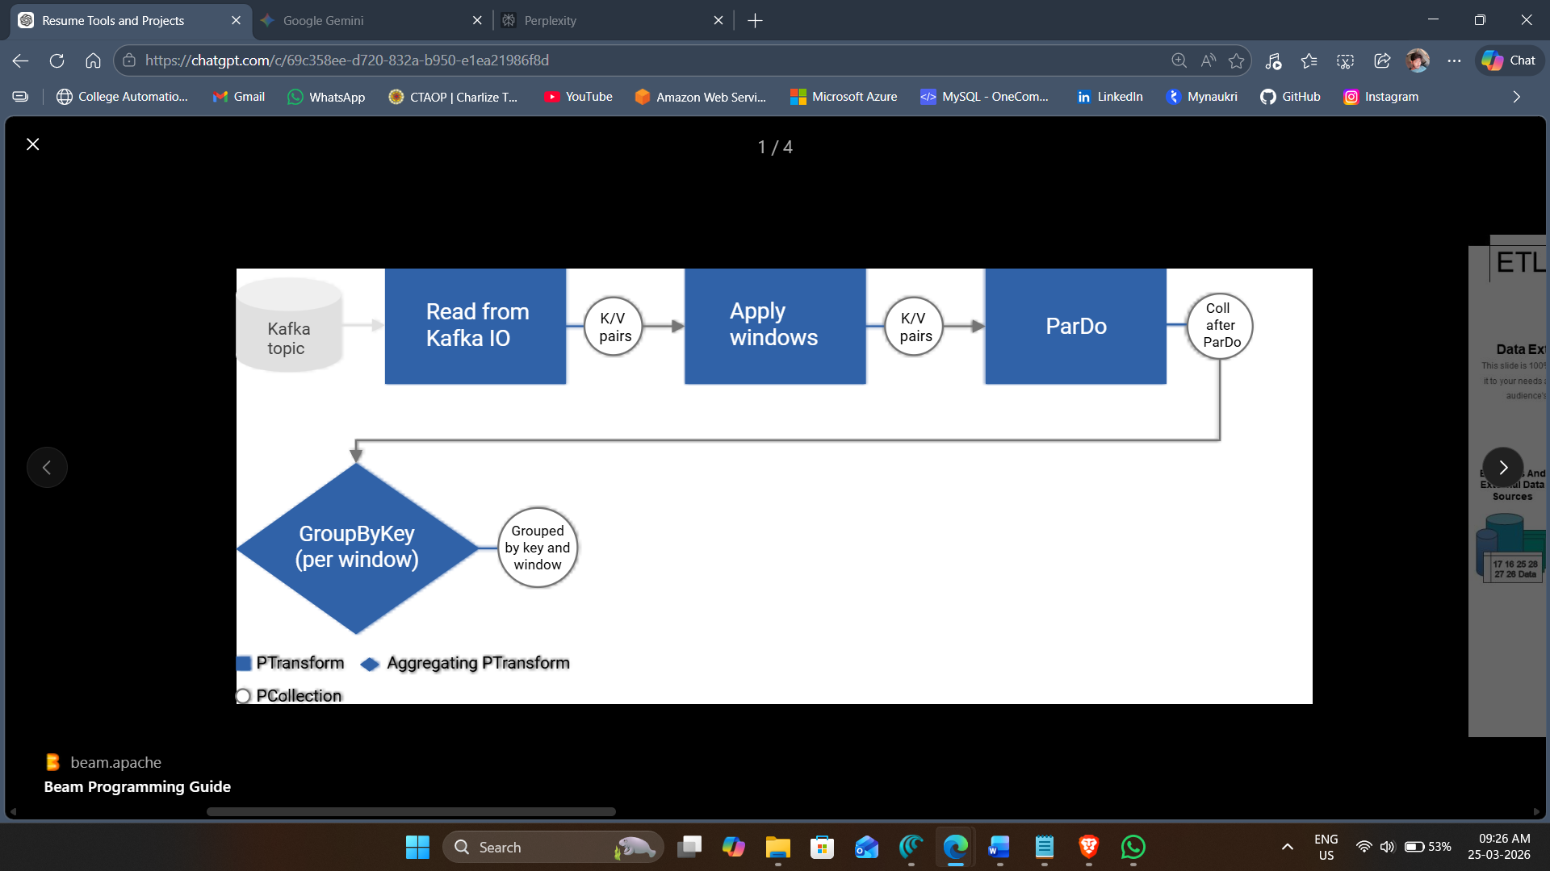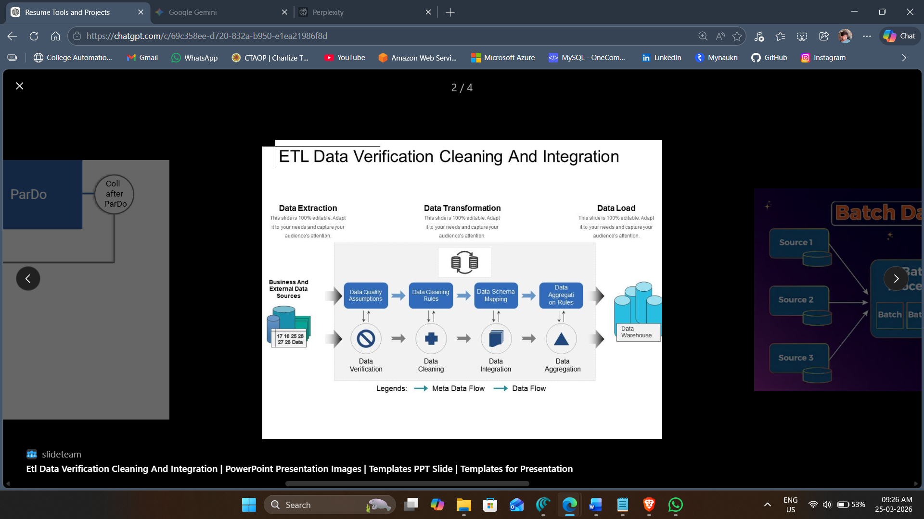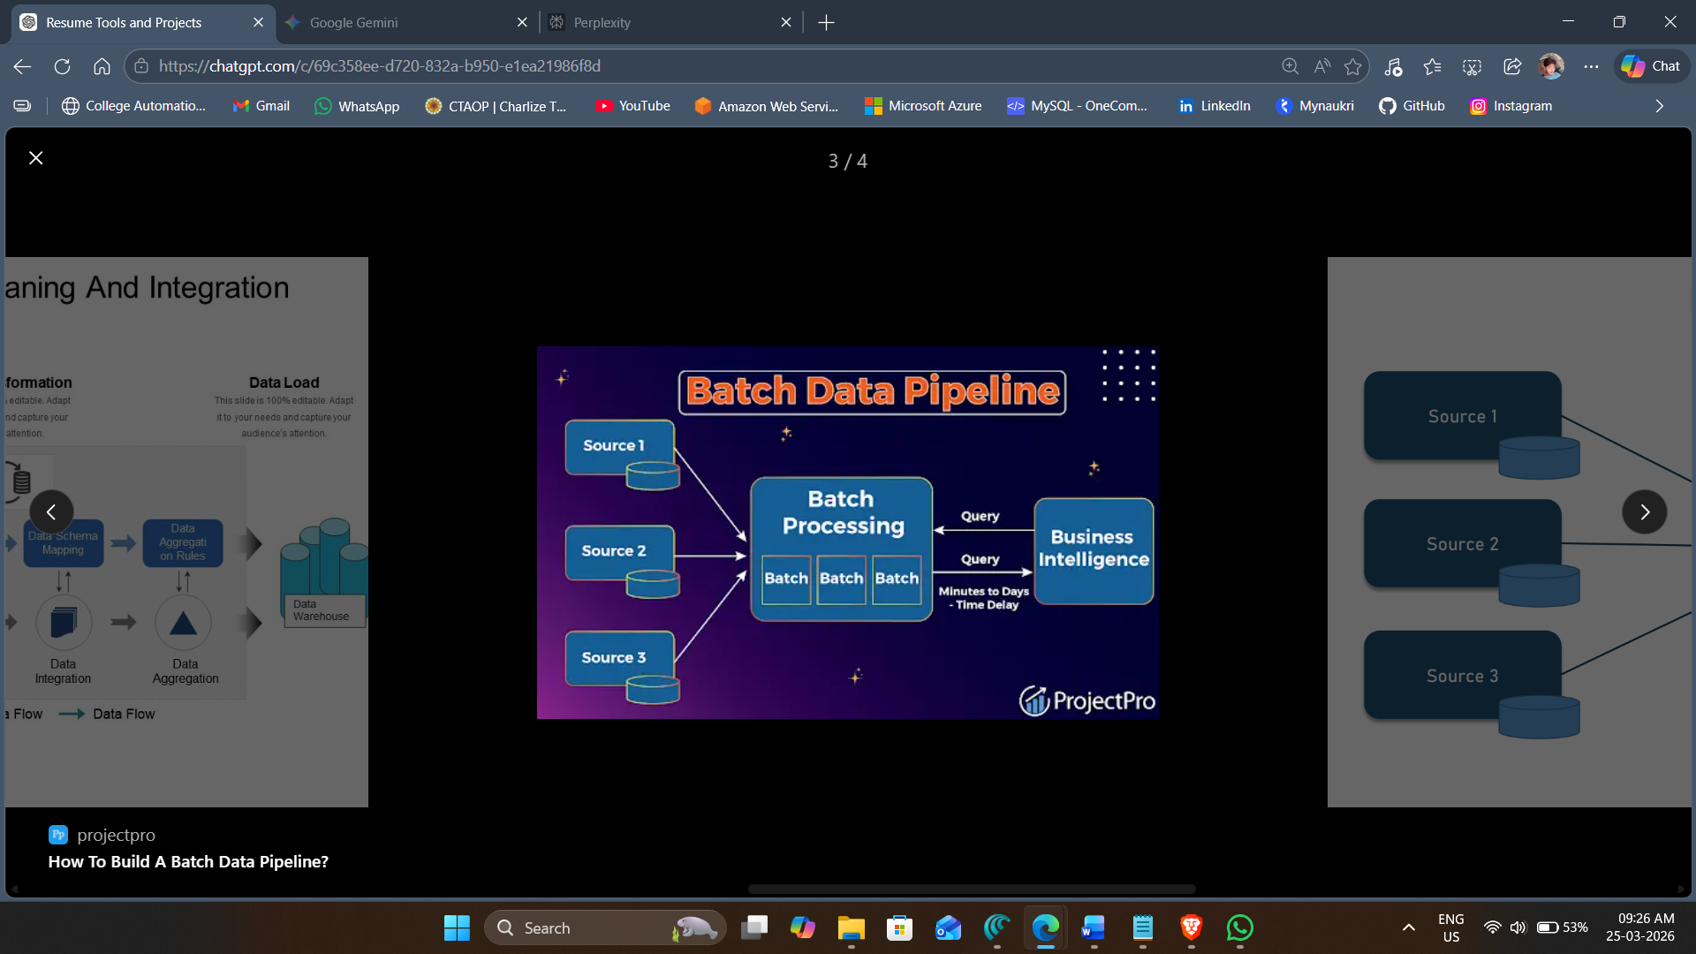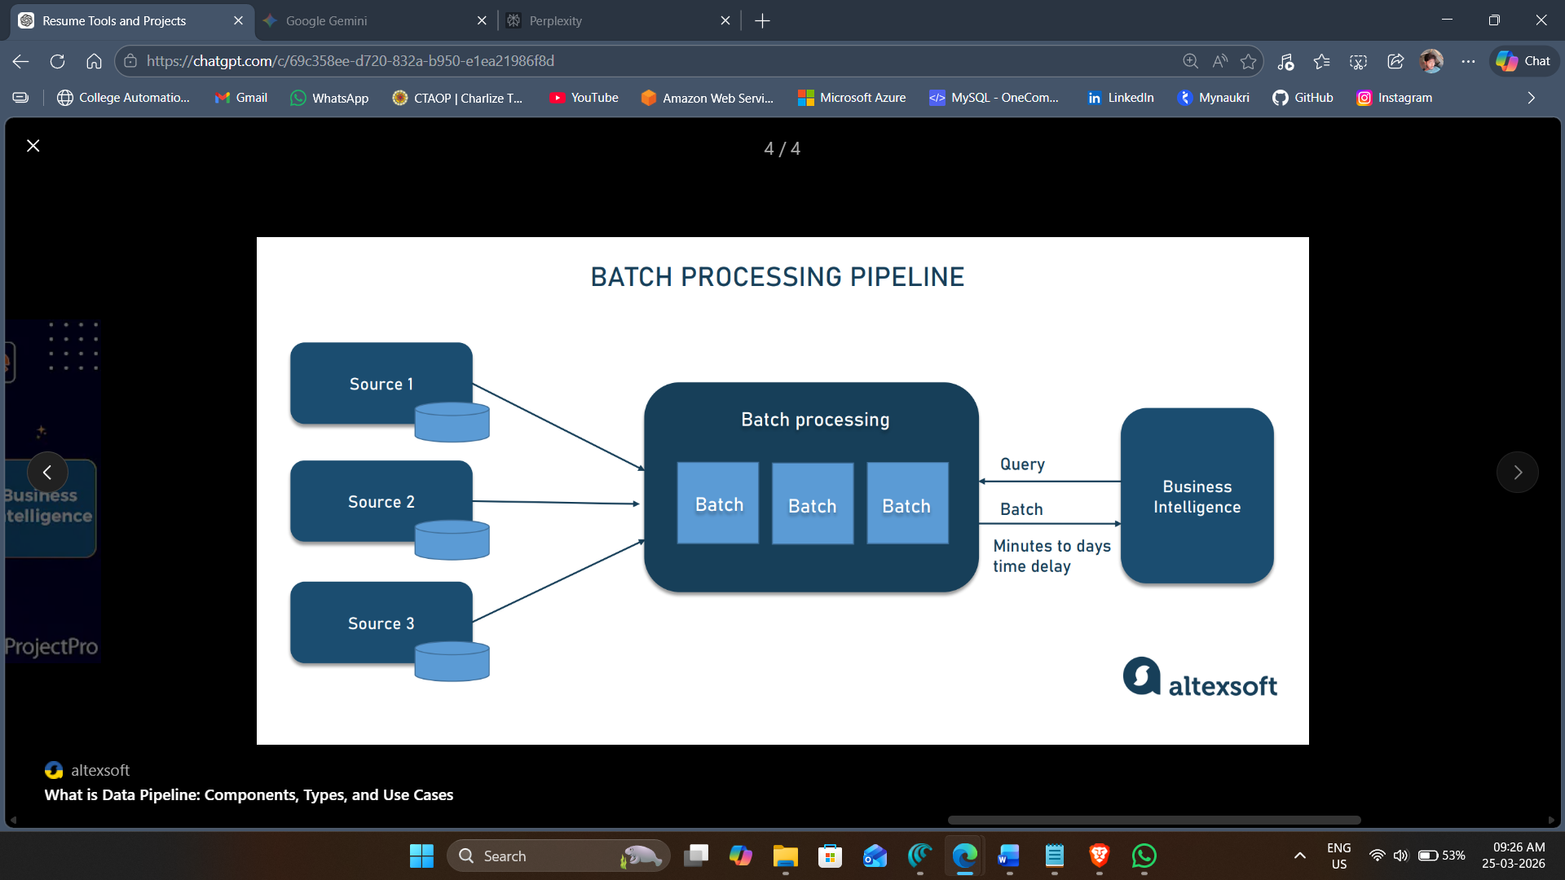
What you did:
- Cleaned and transformed data:
  - Removed null values
  - Converted formats
  - Aggregated data
Tools used:
- Dataflow (Apache Beam)
- Python / PySpark
Simple explanation:
👉 “We clean and transform raw data into usable format.”
Example:
- Raw data:
id | sales
1 | null
2 | 100
- After processing:
id | sales
2 | 100

🔹 Step 3: Real-Time Processing (Streaming)
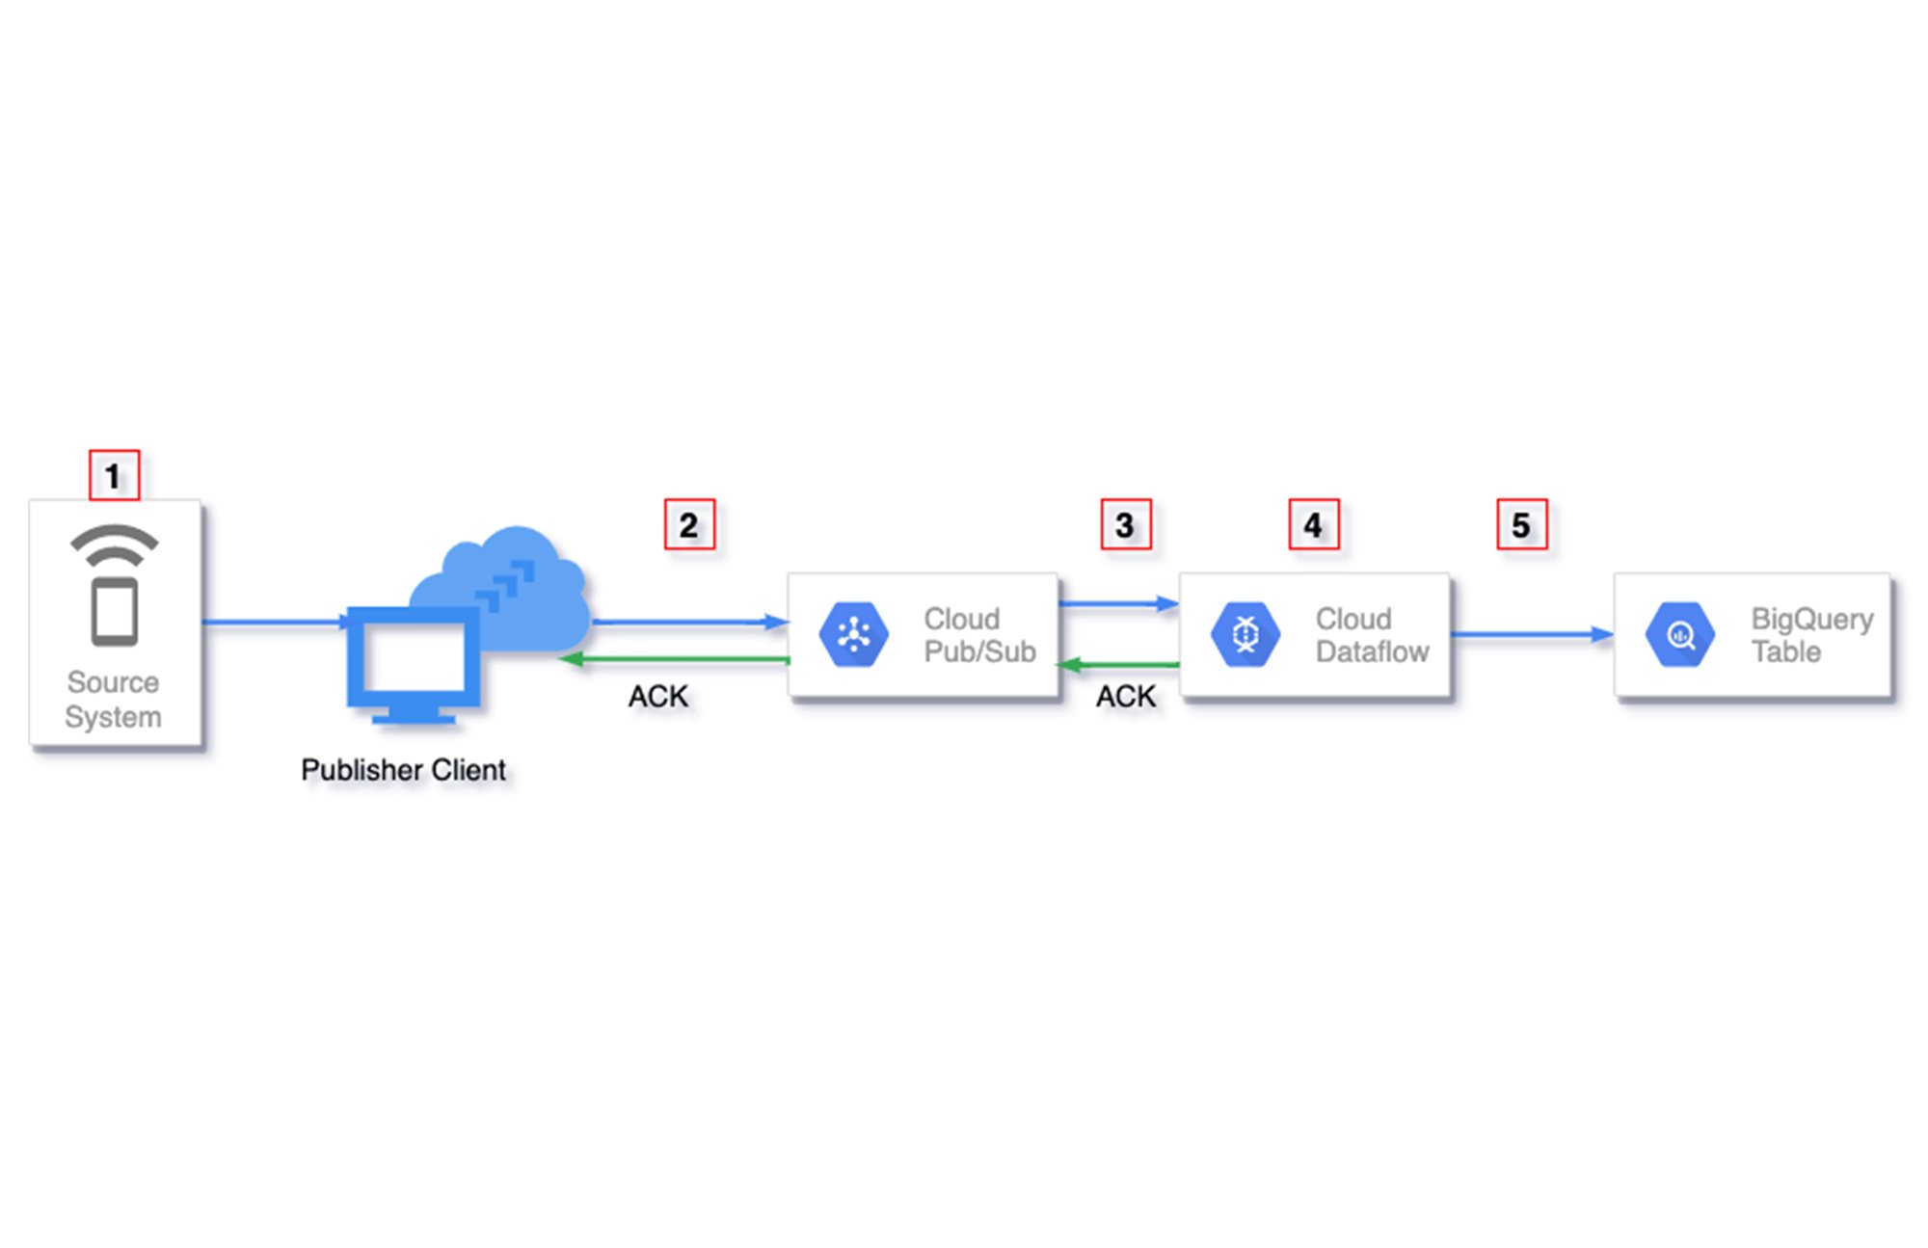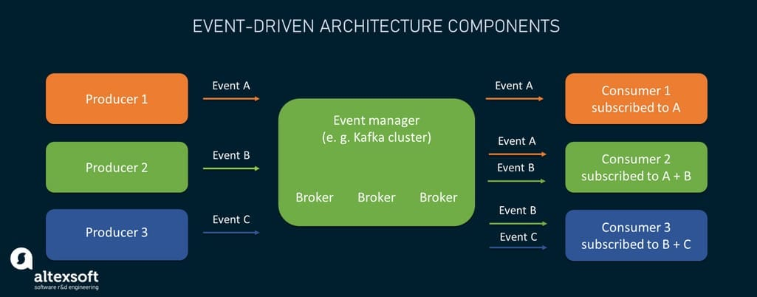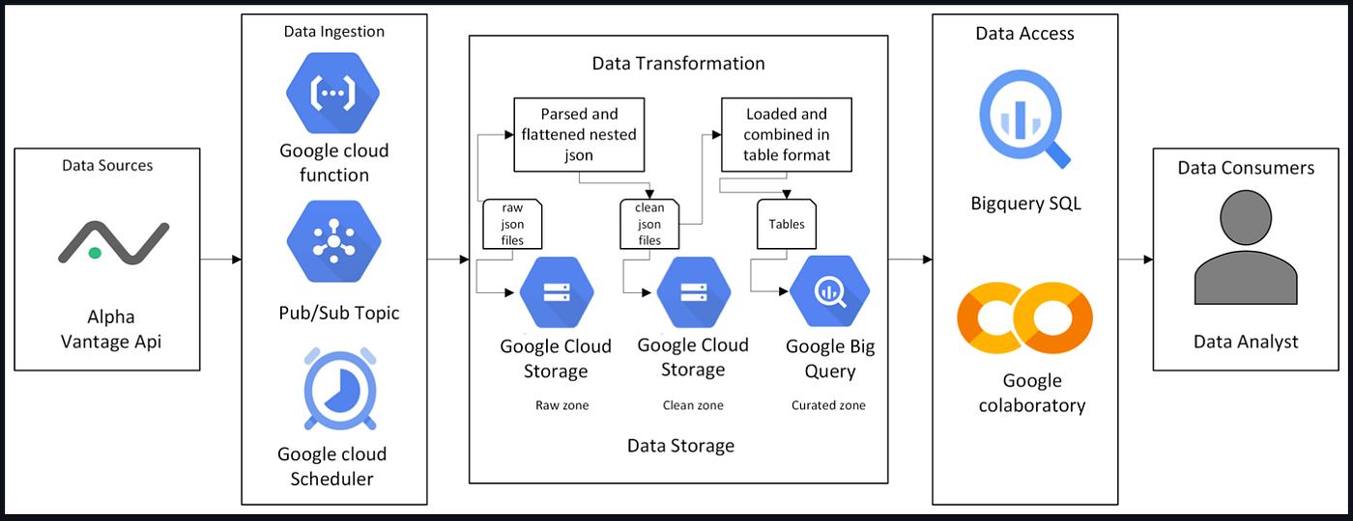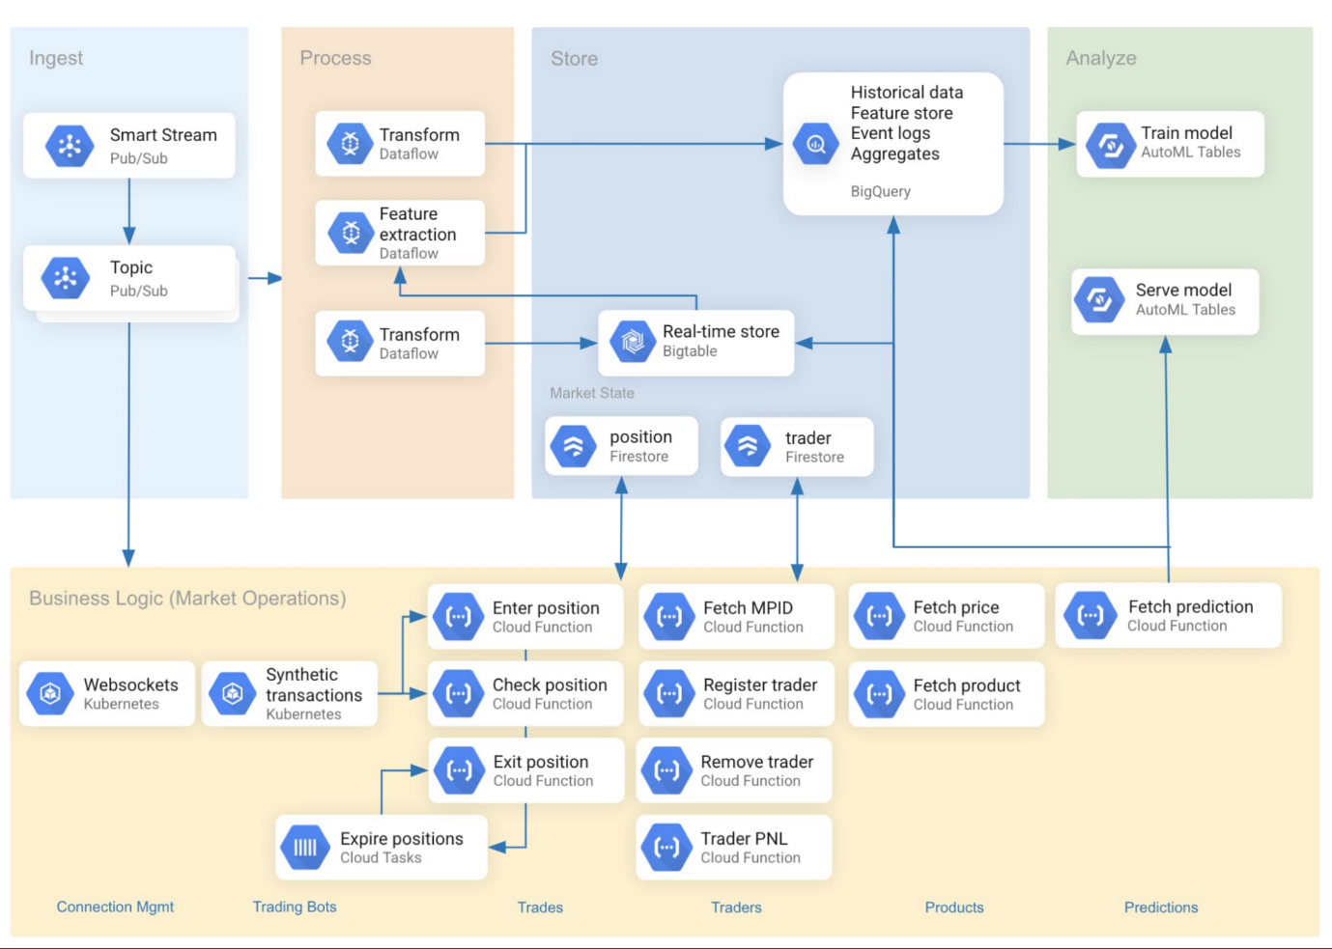
What you did:
- Handled real-time data (like transactions)
Tools used:
- Pub/Sub
- Dataflow (Streaming mode)
Simple explanation:
👉 “For live data, we process it instantly.”
Example:
- User makes payment → event sent → processed immediately

🔹 Step 4: Data Storage (Warehouse)
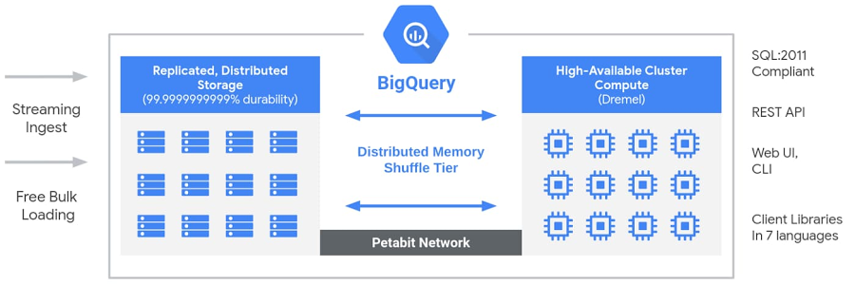
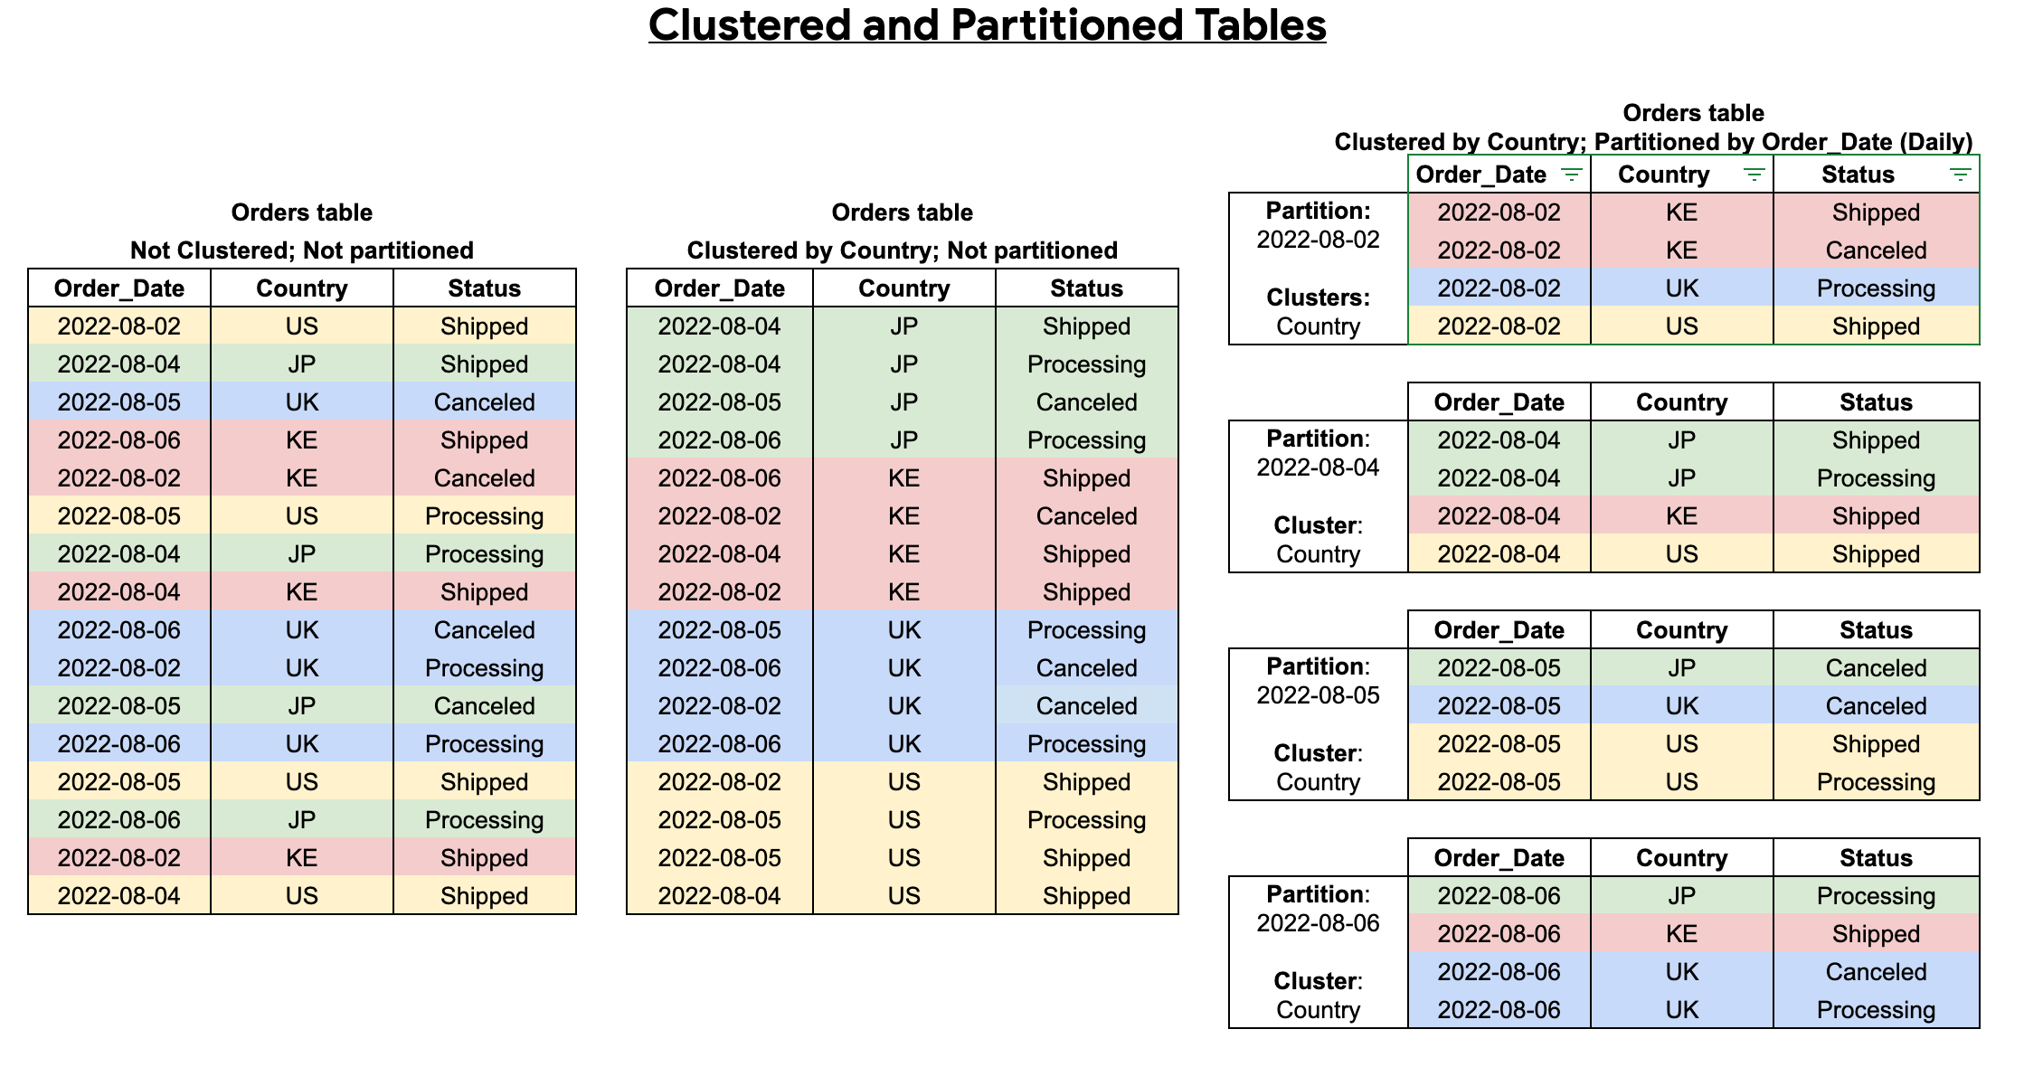
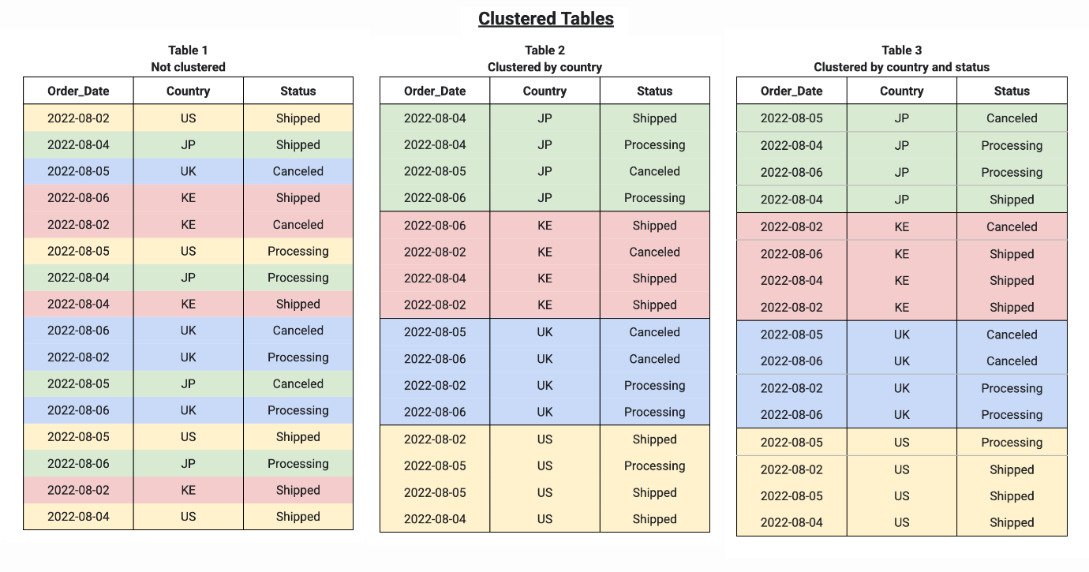
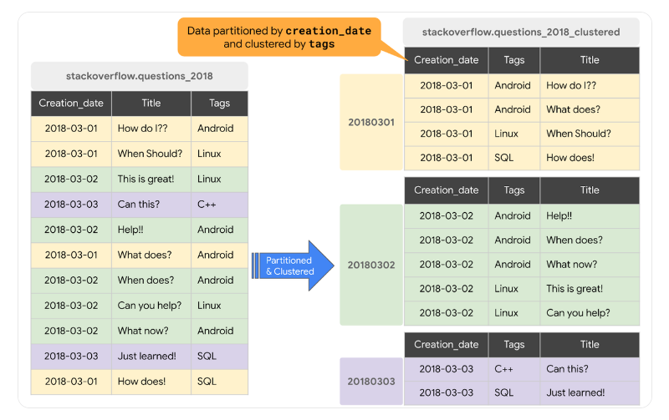
What you did:
- Stored processed data in BigQuery
- Used:
  - Partitioning
  - Clustering

Tools used:
- BigQuery
Simple explanation:
👉 “We store clean data for fast querying and analytics.”
Example:
SELECT total_sales FROM sales_table WHERE date = '2025-01-01';

🔹 Step 5: Workflow Automation
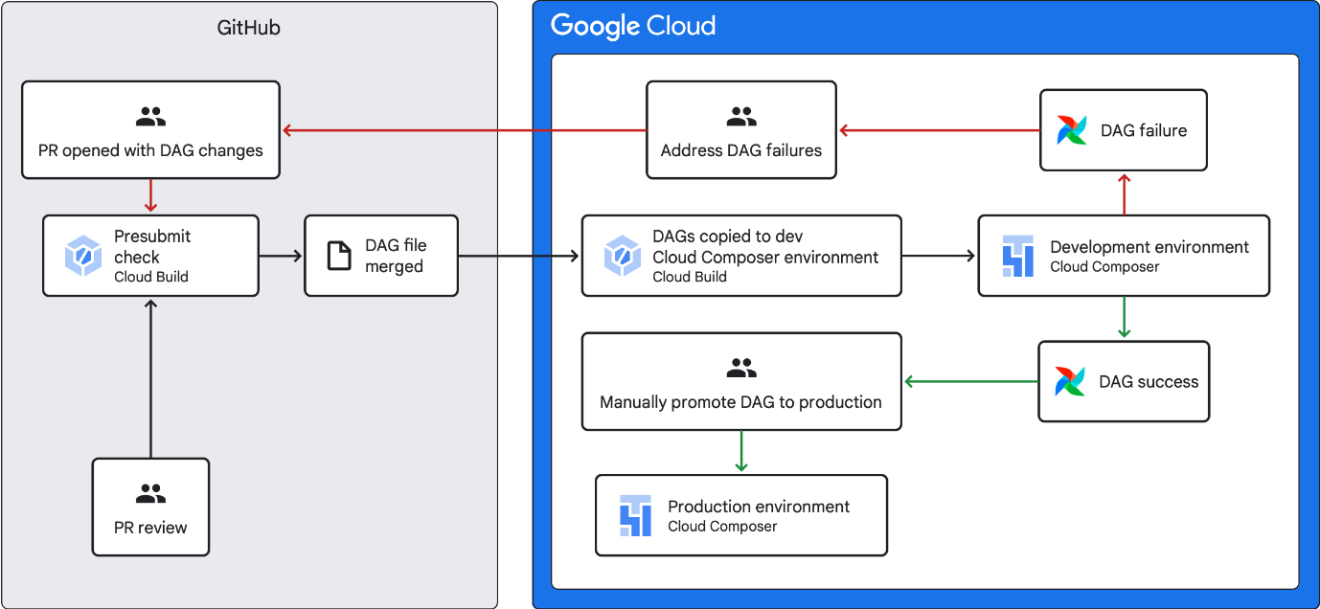
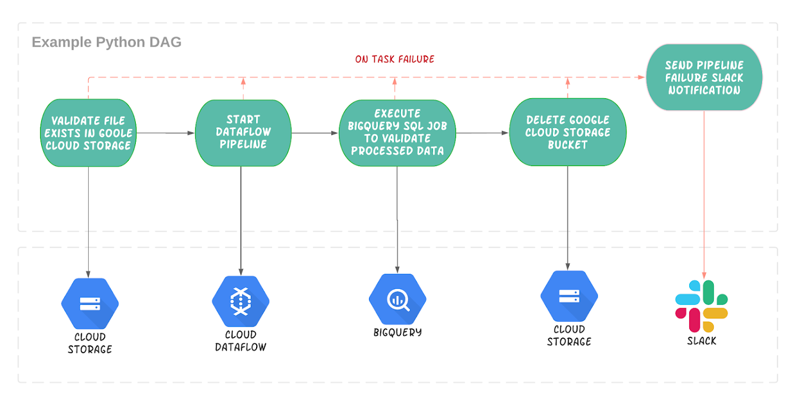
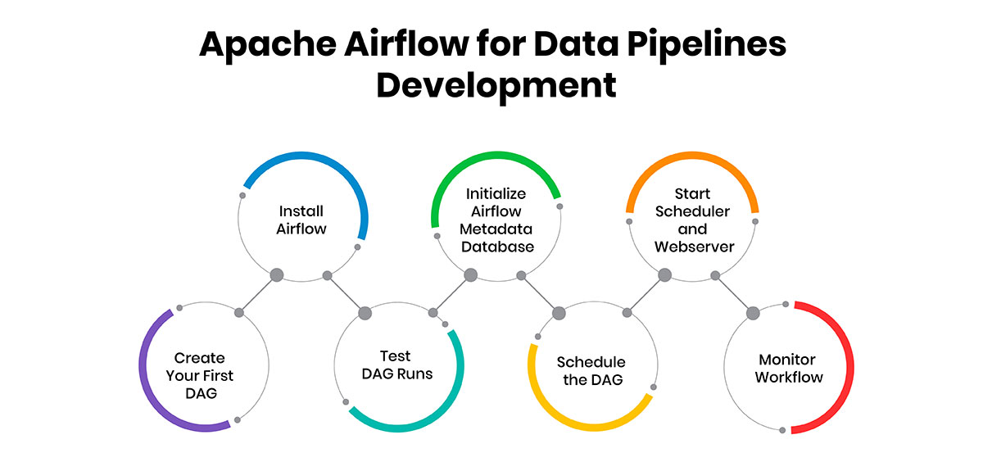
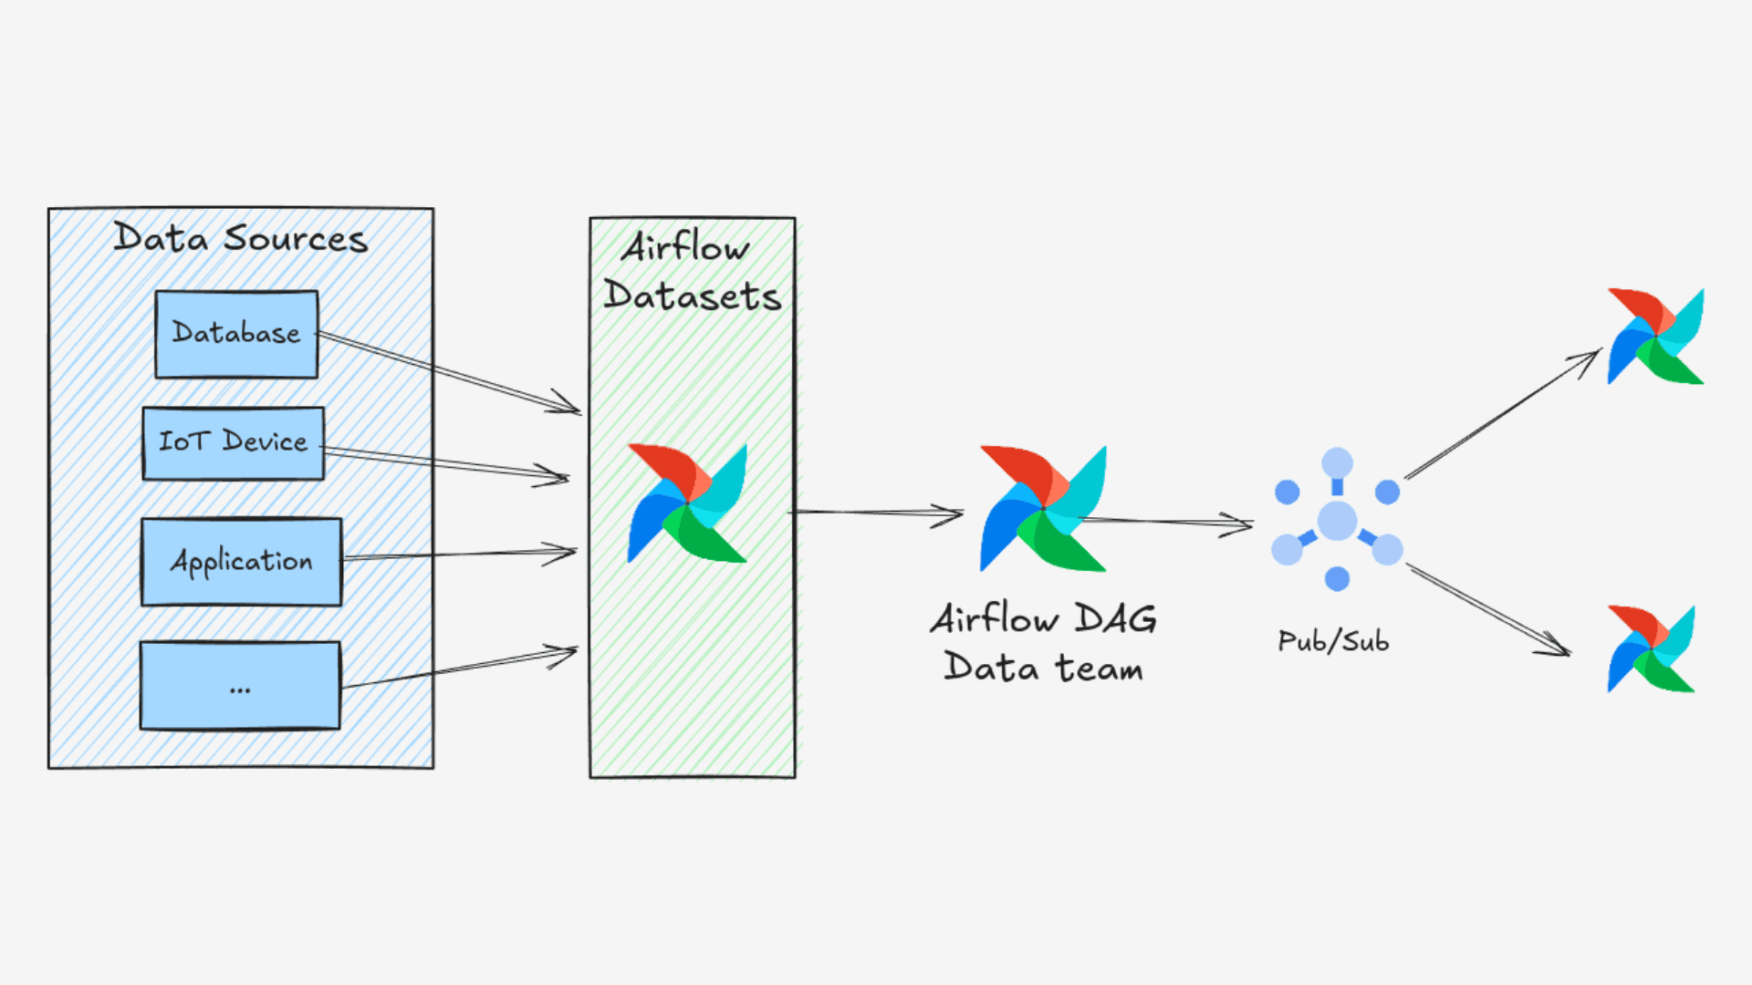
What you did:
- Scheduled pipelines automatically
Tools used:
- Composer (Airflow)
Simple explanation:
👉 “We automated the pipeline to run daily/hourly.”
Example:
- Every day at 2 AM:
  - Load → Process → Store

🔹 Step 6: Performance Optimization
What you did:
- Improved:
  - Query speed (40% faster)
  - Processing time (30% reduction)
Techniques:
- Partitioned tables
- Optimized Dataflow workers
Simple explanation:
👉 “We made the system faster and cheaper.”

🔹 Step 7: Deployment & Version Control
Tools used:
- Terraform → infrastructure setup
- Git/GitHub → version control
Simple explanation:
👉 “We used code to manage infrastructure and track changes.”

🔗 Final Architecture (Say This Clearly)
Source (SAP / Oracle)
↓
GCS (Raw Data)
↓
Dataflow (Processing)
↓
BigQuery (Storage)
↓
Dashboard / Analytics
💡 Final Interview Summary (Best Answer)
You can conclude like this:
“Overall, I built a scalable and reliable data pipeline on GCP using GCS for storage, Dataflow for processing, Pub/Sub for real-time ingestion, and BigQuery for analytics. I also automated workflows using Composer and improved performance using partitioning and optimization techniques, reducing processing time by around 30%.”

🚀 Pro Tip (To Impress Interviewer)
Add this line:
“This architecture was serverless, so it scaled automatically and reduced infrastructure management overhead.”

